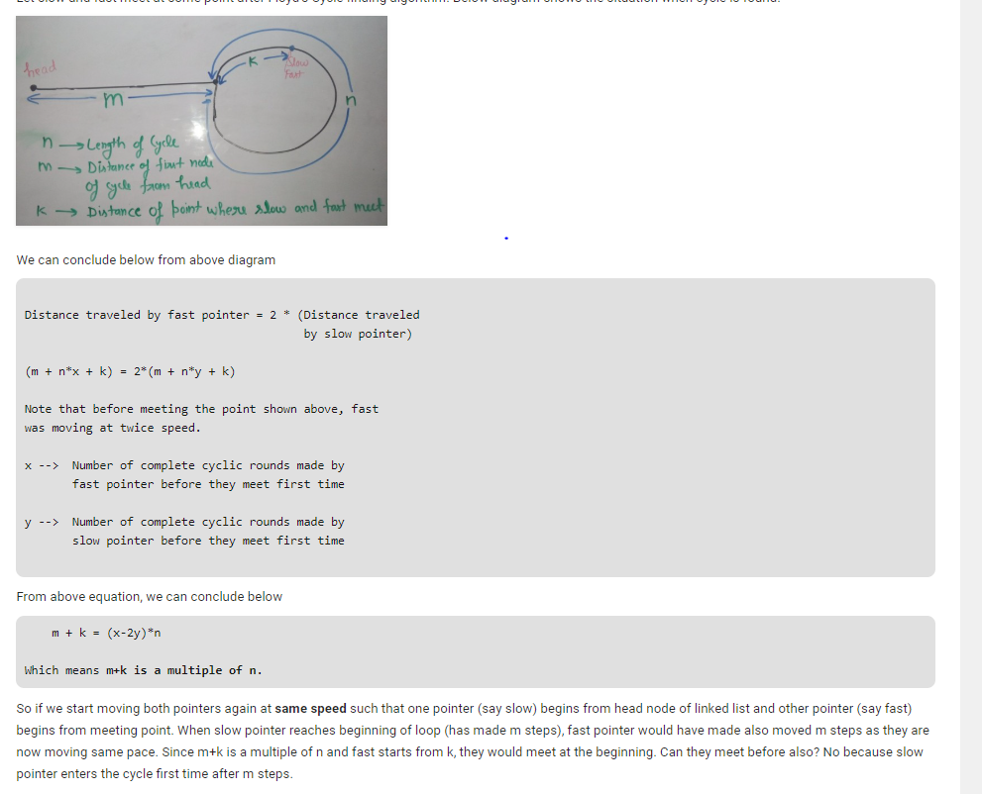ONCE WE DETECT THE LOOP , KEEP THE FAST AT THE POINT OF INTERSECTION AND THE SLOW AS HEAD AGAIN. MOVE BOTH ONE BY ONE , THIS TIME THEY MEET AT THE BEGINNING OF THE LOOP .

CODE:---------------

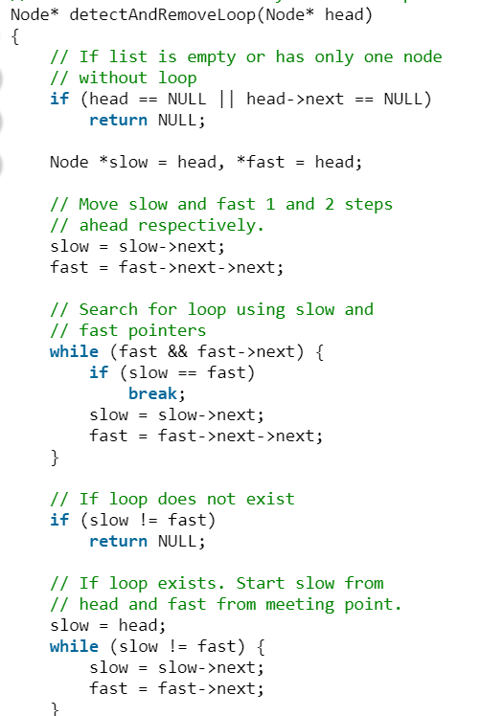

BASIC IDSSEA IS THE SAME

IMP -> CORNER CASES … GO THROUGH THEM .